**Hornsby South**

**Public School**

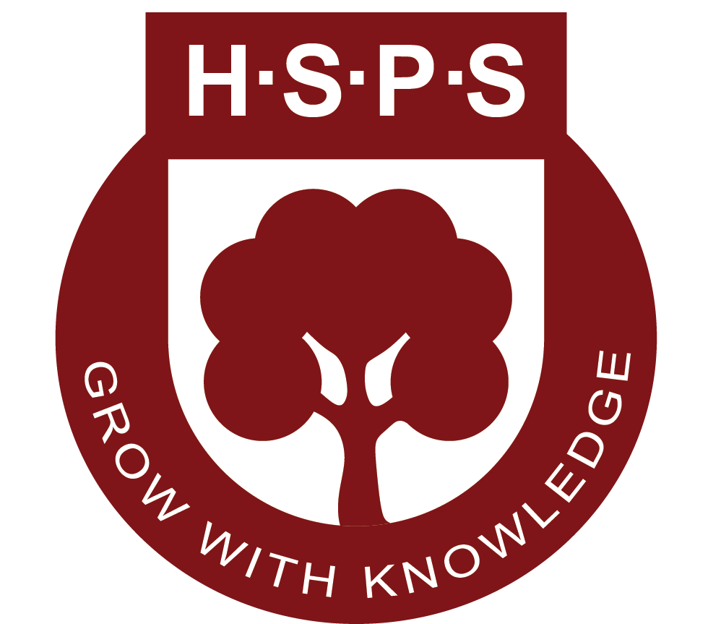

High Potential and Gifted Education Guidelines

**Last review date:** 10 February 2025 **Next review date:** 10 February 2026

|  |
| --- |
| **Rationale** |

Hornsby South Public School supports every student to achieve their educational potential, regardless of their background or personal circumstances. School leaders and teachers use explicit teaching strategies, high expectations and quality teaching to create optimal learning environments where all students are challenged and engaged.

Hornsby South Public School aims to maximise the growth and achievement of High Potential and Gifted (HPG) students across all domains, including intellectual, creative, social-emotional and physical. This is done through evidence-based talent development opportunities and differentiated teaching and learning practices, to ensure that their specific learning and wellbeing needs are met.

|  |
| --- |
| **Definitions** |

**HPG -** High Potential and Gifted

**High Potential** students are those whose potential exceeds that of students of the same age in one or more domains.

**Gifted** students are those whose potential significantly exceeds that of students of the same age in one or more domains.

**Highly Gifted** students are those whose potential vastly exceeds that of students of the same age in one or more domains.

**Talent Development** is the process by which a student’s potential is developed into high achievement in a specific domain or field of endeavour.

**Domains of Potential -**  Intellectual, Creative, Social-Emotional and Physical

**Intellectual Domain** refers to natural abilities in processing, understanding, reasoning, and the transfer of learning.

**Creative Domain** refers to natural abilities in imagination, invention and originality.

**Social-Emotional Domain** refers to natural abilities in self-management and relating to and interacting with others.

**Physical Domain** refers to natural abilities in muscular movement and motor control.

|  |
| --- |
| **Provisions** |

Hornsby South Public School is dedicated to providing developmentally appropriate and engaging programs to support students who demonstrate high potential across a range of domains, including intellectual, creative, social-emotional, and physical. Recognising the diverse needs and abilities of HPG students, Hornsby South Public School strives to foster an inclusive and enriching learning environment that assists them in reaching their full potential.

Teachers select and implement a variety of evidence-based teaching strategies and quality learning experiences. These approaches are thoughtfully designed to engage students’ interests, extend their capabilities, and provide meaningful opportunities for them to explore, innovate, and excel in their areas of strength. Through differentiated instruction and with an emphasis on creativity and critical thinking, teachers aim to enrich the educational experiences of HPG students.

This is achieved through a multi-faceted approach that operates at several levels. At a whole-school level, strategic planning and initiatives ensure that the needs of HPG students are supported. Within individual stages and classrooms, tailored programs and teaching methods are employed to address specific learning goals. Additionally, a wide range of extracurricular activities and enrichment opportunities are offered to provide individual students with broader avenues to develop their talents, collaborate with like-minded peers, and pursue their passions.

**Whole School Approach**

Hornsby South Public School implements evidence-informed programs, practices and procedures so that high potential and gifted students’ specific learning needs are identified and catered for. The school staff includes a range of specialist teachers, including EALD, Learning and Support, creative arts, ICT and PE teachers, to cater for HPG students across a range of domains. A collaborative planning process enables the creation of differentiated learning programs which support the learning and wellbeing needs of HPG students. Extended outcomes are used in the Key Learning Areas, to provide differentiation for high performance. There is a strong focus across the school on promoting creative and critical thinking, and rich, open-ended tasks. For highly gifted students, curriculum compacting, mentoring and acceleration may be undertaken in certain circumstances.

**Classroom Approach**

All teachers develop, design and implement differentiated learning programs with deliberate adjustments to content, process, product and the learning environment to meet the specific learning needs of HPG students. Through ongoing data collection, teachers analyse and evaluate the effectiveness of differentiated programs and provisions.

The [Differentiation Adjustment Tool](https://education.nsw.gov.au/teaching-and-learning/high-potential-and-gifted-education/supporting-educators/implement/differentiation-adjustment-strategies) supports school leaders and teachers in understanding, leading, and creating differentiated learning to meet the learning and wellbeing needs of HPG students across the four domains. It includes a range of specific adjustments that teachers can implement to meet the specific learning needs of HPG students.

Flexible and purposeful grouping is also implemented to further extend HPG students in an area of strength. Flexible grouping strategies may include needs-based or task-oriented grouping – students may be grouped and regrouped frequently, according to formative assessment and learning progress.

***By fostering a culture of high expectations and a love for learning, the school aims to assist HPG students through academic success while developing the confidence, resilience, and skills needed to thrive in a rapidly changing world.***

|  |
| --- |
| **Co-Curricular Activities** |

|  |  |
| --- | --- |
| **Intellectual** | **Creative** |
| The **intellectual domain** of potential refers to natural abilities in processing, understanding, reasoning, and the transfer of learning.   * The Premier’s Spelling Bee * The Premier’s Reading Challenge * Maths Olympiad * Debating * Multicultural Public Speaking Competition * Public Speaking opportunities * Chess Club and Chess Gala Day * Bebras Coding Program * Differentiated teaching programs * ThinkTank Partner School * Science and Technology Enrichment Days * Student Special Interest Projects * NESA WriteOn Competition * Acceleration opportunities for identified students * Code Camp * Young Engineers * Language Classes: Vishna Hindu, Hindi School INC, Taiwanese Language School, Sydney Chinese Language School | The **creative domain**of potential refers to natural abilities in imagination, invention and originality.   * School band, music tuition and performances * Key Music * Band Camp * String Ensemble * Creative Arts performance opportunities e.g. Wakakirri, Primary Proms * Junior and Senior Choirs * Drama Club * Extra-curricular Art club/lessons * WriteOn competition * The Music Bus * Year 6 Graduation Book Committee * Art Class * Bush studio: Field of Mars Art Enrichment Day |
| **Social and Emotional** | **Physical** |
| The **social-emotional**domain of potential refers to natural abilities in self-management and relating to and interacting with others.   * Leadership Opportunities e.g. Leadership Team, Student Representative Council, House Captains * Participation in the leadership conference * Buddy Programs * Debating Camp * Peer Mentoring Program | The**physical domain** of potential refers to natural abilities in muscular movement and motor control.   * Dance Groups * HZSS summer and winter sport teams (Yr 3-6) * After school sports groups and coaching * Gala Day Activities * TIG Day * Track and Field events, Cross Country and Swimming Carnivals (Ages 8-12) * The Premier’s Sporting Challenge * Dedicated sports teacher * T3 Football Clinic * Sporting leadership opportunities/peer coaching * GKR Karate * Zone trials for Sydney North Teams |

|  |
| --- |
| **Identification Procedures** |

The identification of high-potential and gifted students must be thorough, valid, and reliable, incorporating both quantitative and qualitative data. This data is continuously used to inform teaching and learning across all domains of potential. By drawing on diverse data sources and involving all stakeholders, we ensure that students from all backgrounds—including culturally and linguistically diverse students, those from varied socio-economic contexts, Aboriginal and Torres Strait Islander students, and students with disabilities—have equal access to opportunities that support their growth and achievement.

**Teacher Nomination Process**

Classroom, specialist, and support teachers can nominate students with high potential in one or more domains using the Teacher Nomination Form (see below) and theHPGE Identification Checklist. Nominations are reviewed in collaboration with a member of the HPGE Committee and the Learning and Support Team to ensure a comprehensive and informed process.

* *Teacher Nomination Form:* [***https://drive.google.com/file/d/1iukwSTR-HH6PdqK-Ln37SaaYFtWRiaHZ/view***](https://drive.google.com/file/d/1iukwSTR-HH6PdqK-Ln37SaaYFtWRiaHZ/view)

**Parent Nomination Process**

Parents provide valuable insights into their child's strengths, areas for growth, interests, and passions, as well as their social interactions beyond the school environment. Parents who wish to nominate their child in one or more domains are encouraged to meet with the classroom teacher to discuss their child’s learning needs before completing the Parent Nomination Form.

* *Parent/Carer Nomination Form:* [***https://drive.google.com/file/d/13HDgdrXW4fYBgn5qaw37E10WJaViKMam/view***](https://drive.google.com/file/d/13HDgdrXW4fYBgn5qaw37E10WJaViKMam/view)

**Student Nomination Process**

Students offer valuable insights into their own strengths. By reflecting on their experiences, interests, and aspirations, they can help shape learning experiences that are both engaging and meaningful. Encouraging students to share their perspectives fosters a sense of ownership over their learning while also providing educators with a deeper understanding of how to support and nurture their potential. Students who wish to nominate themselves can do so by completing the Student Nomination Form, which should be submitted only after discussing their nomination with their classroom teacher and/or grade supervisor.

* *Student Nomination Form:* [***https://drive.google.com/file/d/1wMyxIP3U66Hqtav23rvs27BtkhOykuiE/view***](https://drive.google.com/file/d/1wMyxIP3U66Hqtav23rvs27BtkhOykuiE/view)

|  |
| --- |
| **Monitoring** |

The monitoring of High Potential and Gifted (HPG) students is managed collaboratively by the HPGE Coordinators and the Learning and Support Team.

Adjustments and provisions for these students are developed, planned and reviewed with classroom teachers, parents and the student at least twice a year or as needed. Highly gifted students, as well as twice-exceptional students (those who are both gifted and have a disability), receive additional monitoring and support through the Learning and Support Team.

This process includes careful consideration of factors that may influence a student’s academic progress and overall wellbeing. Some challenges may include:

* Disengagement
* Underachievement
* Perfectionism (fear of failure)
* Extreme sensitivity (overexcitabilities)

|  |
| --- |
| **Teacher Responsibilities** |

The following outlines key responsibilities for teachers in supporting HPGE students through assessment, collaboration, differentiation, and evidence-informed strategies.

* Use assessment and data to assess and identify the specific learning needs of HPG students across all domains of potential
* Collaborate with HPG coordinators or committee members to support the needs of HPG students
* Apply evidence-based approaches that extend and challenge HPG students beyond their current level of mastery
* Develop, design and teach differentiated learning programs and provide experiences that meet the advanced learning needs of HPG students
* Undertake professional learning that enhances their expertise in planning and programming effective learning experiences for HPG students across all domains of potential
* Collaborate with families, school communities and external agencies/specialists to support the talent development of HPG students
* Communicate assessment and identification information about HPG students to support transition

